**PETER SANKALE KOPEJO**

**TITLE: BARE SOIL MAPPING USING MULTISPECTRAL REMOTE SENSING IMAGERY; A CASE STUDY OF NYANDARUA COUNTY.**

**PROJECT PROGRESS SUMMARY REPORT**

INTRODUCTION

This project aims to develop a Synthetic Soil Image of Nyandarua County, utilizing a time series of Landsat 8 imagery for the period: 2013 to 2023.

The Project Objectives:

* To produce a bare soil map of Nyandarua County using remote sensing techniques
* To develop a model for analysing a time series of imagery to collect bare soil masks and combine them to form a full bare soil map of the area
* To analyse various soil properties from the mapped bare soil map such as soil moisture

The Methodology (Refined from the initial progress report), I have used is illustrated below:

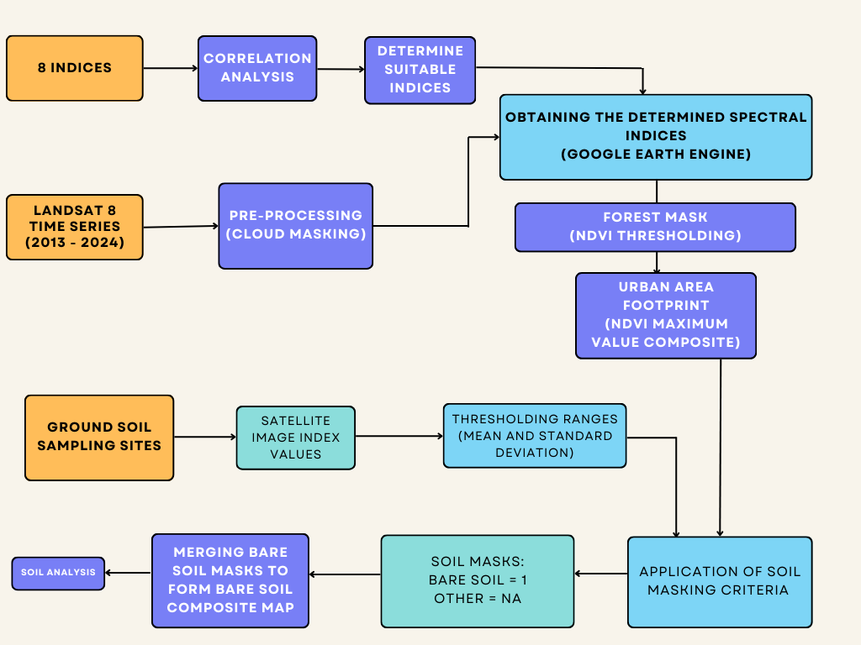

1. THE 8 INDICES

NDVI

Calculated as (NIR-Red) / (NIR+Red)

Compared to healthy plants, bare earth reflects more red light and less near-infrared light. Depending on the kind of soil, moisture content, and surface roughness, reflectance might vary. Because there is typically less of a difference between the NIR and red reflectance in bare soil, it has a lower NDVI value than in vegetated areas.

Vegetation strongly reflects NIR light due to the cellular structure of its leaves, which are designed to scatter NIR light while absorbing red light for photosynthesis. The absence of these structures in bare soil means that there's less NIR light being reflected, contrasting with the way vegetation behaves.

Since bare soil typically results in lower NDVI values, the index can be used to identify areas with little to no vegetation. By setting a threshold NDVI value, areas below this threshold can be flagged as bare soil.

NBR2

Calculated as: (SWIR1-SWIR2) / (SWIR1+SWIR2)

Obtained from the Geospatial Soil sensing method or system (GEOS3), used to distinguish between Bare soil and straw and burnt vegetation which is difficult using only NDVI.

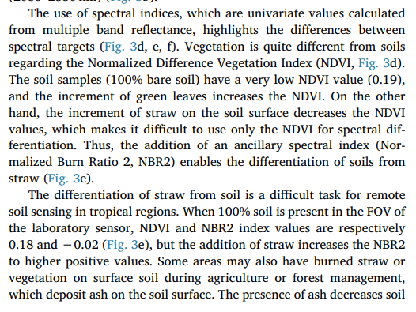

Generally, bare soil has a moderate to low NBR2 value, reflecting its intermediate reflectance properties between those of healthy vegetation and burnt areas.

The lower moisture content and changed the physical structure of straw or vegetation following a harvest or fire increase their reflectance in the SWIR bands, particularly in SWIR 2. As a result, as the difference in SWIR2 and SWIR1 reflectance grows, burned regions and straw typically have greater NBR2 values than healthy vegetation. Because of this, NBR2 is a helpful index for determining the presence and extent of burn scars as well as separating harvested fields from bare ground or unburned vegetation.

BAND 3 - BAND 2

Calculated as: Green – Blue

Obtained from the Geospatial Soil sensing method or system (GEOS3).

Band 3: Captures light in the blue wavelength range (approximately 450-515 nm for Landsat 8). Blue light is generally absorbed by vegetation but reflected by surfaces with little to no vegetation, including bare soil, water, and urban areas.

Band 2: Captures light in the green wavelength range (approximately 525-600 nm for Landsat 8). Green light is reflected by healthy vegetation more than blue or red light due to the chlorophyll content, making this band useful for assessing plant health and coverage. Bare soil tends to reflect less green light compared to blue light

Bare soil can reflect both blue and green light, but the amount and ratio of this reflectance can significantly differ from that of vegetated surfaces. Typically, soil reflects more blue light compared to green, but the exact ratio can depend on the soil type and condition. By analysing the difference or ratio between the green and blue bands, one can infer the presence of bare soil based on lower values (indicating relatively less green light reflectance compared to blue).

BAND 2 – BAND 1

Calculated as: Blue – Ultra Blue

Obtained from the Geospatial Soil sensing method or system (GEOS3).

Bare Soil reflects more light in the blue band compared to the coastal/aerosol band. This contrast can help distinguish bare soil from other surfaces, such as vegetation or water, which either absorb more blue light or have different reflective properties in these spectral bands.

Modified Bare Soil Index (MBI)

Calculated as: (SWIR1 – SWIR2 – NIR) / (SWIR1 + SWIR2 + NIR)

Obtained from the article: ‘A Modified Bare Soil Index to Identify Bare Land Features during Agricultural Fallow-Period in Southeast Asia Using Landsat 8‘

**Shortwave Infrared 1 (SWIR 1):** Light in this band, which is sensitive to soil and plant moisture levels, is in the shortwave infrared spectrum. For instance, SWIR 1 correlates to Band 6 in the context of Landsat 8. In comparison to vegetated regions, bare soil frequently reflects more SWIR 1 light, particularly when the soil is dry.

**Shortwave Infrared 2 (SWIR 2):** Similar to SWIR 1 but at a slightly longer wavelength. SWIR 2 is also sensitive to moisture but is particularly useful in distinguishing mineral compositions and texture of the soil. Bare soil can show different reflectance in SWIR 2 based on its texture and moisture content.

**Near-Infrared (NIR)**: This band is highly reflected by healthy vegetation due to the internal structure of leaves but less so by bare soil or unhealthy vegetation. The NIR band serves as a contrast to the SWIR bands in the MBI formula, helping to suppress the signal of vegetated areas and enhance that of bare soil.

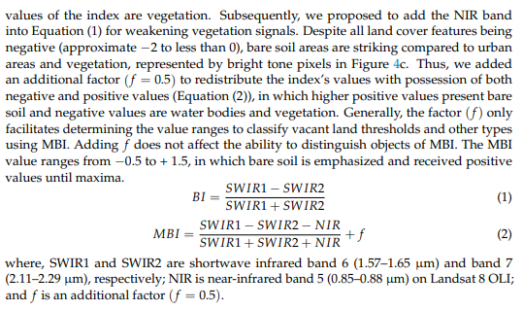

Dry Bare Soil Index (DBSI)

Calculated as: (((SWIR 1 – Green) / (SWIR 1 + Greed)) – ((NIR – Red) / (NIR + Red)))

* **Shortwave Infrared 1 (SWIR 1)**: Reflects light in the shortwave infrared range. This band is sensitive to moisture content in the soil and vegetation. Dry soil reflects more in this band compared to moist soil or vegetation, making SWIR 1 crucial for identifying dry bare soil conditions.
* **Green**: Captures light in the green visible spectrum. Vegetation strongly reflects green light, whereas bare soil reflects less. The green band helps in distinguishing vegetated areas from non-vegetated ones.
* **Near-Infrared (NIR)**: Highly reflected by healthy vegetation due to the internal structure of leaves, but less so by bare soil or unhealthy vegetation. This band is used to assess vegetation presence and vitality.
* **Red**: Absorbed by healthy vegetation for photosynthesis and reflected by surfaces with little or no vegetation. The red band assists in detecting areas with low vegetation coverage, such as bare soil.

First Component (SWIR1 - Green) / (SWIR1 + Green): This part of the formula aims to highlight areas of dry soil. Dry bare soil has higher reflectance in the SWIR 1 band compared to the Green band. The ratio emphasizes the contrast between dry soil and areas with moisture or vegetation.

Second Component (NIR - Red) / (NIR + Red): This portion, similar to the calculation for NDVI, focuses on vegetation presence. Healthy vegetation has high NIR and low Red reflectance, resulting in positive values. Bare soil, especially when dry, tends to have lower differences between NIR and Red reflectance, resulting in values closer to zero or negative.

By subtracting the vegetation component from the dry soil component, DBSI effectively isolates dry bare soil areas. High DBSI values indicate dry bare soil, as the index accentuates the soil's dryness (high SWIR 1 reflectance relative to Green) while minimizing the influence of vegetation (lower NIR reflectance relative to Red).

Normalized Difference Bareness index (NDBaI)

Calculated as: (SWIR 1 – TIR) / (SWIR 1 + TIR)

**Features of Bare Soil:** Due to its surface temperature, bare soil, which is devoid of vegetation cover, usually exhibits higher reflectance in the SWIR band and higher emission in the TIR band. In dry, exposed soil conditions with little moisture to adjust temperature or SWIR reflectance, these features are particularly noticeable.

**NDBaI for Flagging Bare Soil:** A high value corresponds to a surface that is consistent with bare soil's properties, such as high thermal emission and high SWIR reflectance. On the other hand, lower or negative NDBaI values indicate the presence of water or vegetation. Because evapotranspiration from these sources cools the environment, vegetation and water bodies usually have lower TIR emission and lower SWIR reflectance.

Bare Soil Index (BSI)

Calculated as: (((SWIR 2 + Red) – (NIR + Blue)) / ((SWIR 2 + Red) + (NIR + Blue)))

**Shortwave Infrared 2 (SWIR 2):** Reflects light in the shortwave infrared spectrum, which is affected by soil and vegetation structure, moisture content, and both. When determining moisture changes in soil and vegetation, this band is especially helpful. This translates to Band 7 for Landsat 8.  
  
**Red:** Surfaces with little to no plant, like bare soil, reflect this band, which is absorbed by chlorophyll in healthy vegetation. It's employed to find the density and health of the vegetation. This translates to Band 4 for Landsat 8.  
  
**NIR:** Healthy vegetation reflects NIR (near-infrared radiation) more than bare soil or poor vegetation. For recognizing vegetated areas, it works well.

**Bare Soil Characteristics**: Bare soil has a distinct spectral signature that differs from vegetated surfaces. It tends to reflect more in the SWIR and Red bands due to its physical and chemical properties and less in the NIR and Blue bands compared to vegetative cover.

**BSI Calculation**: The index calculation aims to accentuate the presence of bare soil by combining these spectral characteristics. The numerator ((SWIR2 + Red) - (NIR + Blue)) increases with higher reflectance in the SWIR2 and Red bands, which is typical for bare soil. Conversely, the reflectance in the NIR and Blue bands, indicative of vegetative cover and water, respectively, reduces this value.

**Interpreting BSI Values**: Higher BSI values indicate a stronger presence of bare soil characteristics, whereas lower or negative values suggest the dominance of vegetation or water. This makes the BSI particularly useful for mapping bare soil areas, assessing land cover changes, or monitoring agricultural lands.

Normalized Difference Soil Index 1 (NDSI1)

Calculated as: ((SWIR 1 – NIR) / (SWIR 1 + NIR))

**Bare Soil Characteristics**: Bare soil generally reflects more in the SWIR 1 band and less in the NIR band, especially when the soil is dry and lacks vegetation cover. This difference in reflectance is due to the soil's physical and chemical properties, which can vary depending on the soil type, moisture content, and surface texture.

**Vegetation Characteristics**: Vegetated areas, on the other hand, exhibit high reflectance in the NIR band and lower reflectance in the SWIR 1 band due to the presence of chlorophyll and the internal structure of leaves, which efficiently scatter NIR light.

**Interpreting NDSI1 Values**: Higher NDSI1 values indicate the presence of bare soil, as the formula emphasizes the soil's reflectance in the SWIR 1 band relative to the NIR band. Conversely, lower or negative NDSI1 values suggest the presence of vegetation, as the NIR reflectance dominates.

Normalized Difference Bare land index (NBLI)

Calculated as: ((Red – TIR) / (Red + TIR))

Features of Bare Soil: Due to greater surface temperatures, bare soil tends to reflect more in the red band and emit more in the TIR band, especially when exposed to sunshine. The soil's temperature affects its emission in the TIR band, while its physical and chemical characteristics can affect its reflectance in the Red band.  
  
Vegetated regions: On the other hand, because they transpire more often and absorb a greater amount of red light for photosynthesis, vegetated regions usually have lower surface temperatures and produce less TIR emissions.

**Interpreting NBLI Values**: Higher NBLI values suggest the presence of bare land, as the formula accentuates the reflectance in the Red band relative to the thermal emission. Conversely, lower or negative NBLI values indicate cooler, possibly vegetated surfaces where TIR emissions are lower relative to Red reflectance.

Modified Normalized Difference Soil Index (MNDSI)

Calculated as: ((SWIR 2 – PAN) / (SWIR 2 + PAN))

**Bare Soil Characteristics**: Bare soil reflects more in the SWIR 2 band compared to many other surfaces due to its unique moisture content and texture. The PAN band, capturing a broad range of the visible to near-infrared spectrum, can provide a high-resolution base for contrasting against the SWIR 2 responses.

**Interpreting MNDSI Values**: Higher MNDSI values typically indicate the presence of bare soil. This is because the index formula emphasizes areas where the SWIR 2 reflectance is relatively higher than the reflectance in the PAN band, a characteristic of bare soil surfaces, especially those with low moisture content.

Bareness Index (BI)

Calculated as: Red + SWIR 1 – NIR

**Bare Soil Characteristics**: Bare soil generally has higher reflectance in the Red and SWIR 1 bands compared to vegetated areas. The addition of Red and SWIR 1 reflectance values, minus the NIR reflectance, accentuates the presence of bare soil. This is because bare soil's signature is more pronounced in these bands than in the NIR band, where vegetation would otherwise dominate the signal.

**Interpreting BI Values**: Higher values of the BI are indicative of bare soil or sparsely vegetated areas, as these locations reflect more light in the Red and SWIR 1 bands and less in the NIR band. Conversely, areas with dense vegetation, which strongly reflect NIR and absorb Red light, would yield lower values of the BI.

1. CORRELATION ANALYSIS

I performed a correlation analysis of the monthly index values for the year 2016, in order to determine which indices to use to minimize redundancies due to different indices having similar functionalities of responses to the same target element which in this case is bare soil.

The results are displayed below:

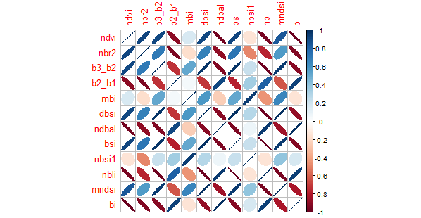

CORRELATION ANALYSIS

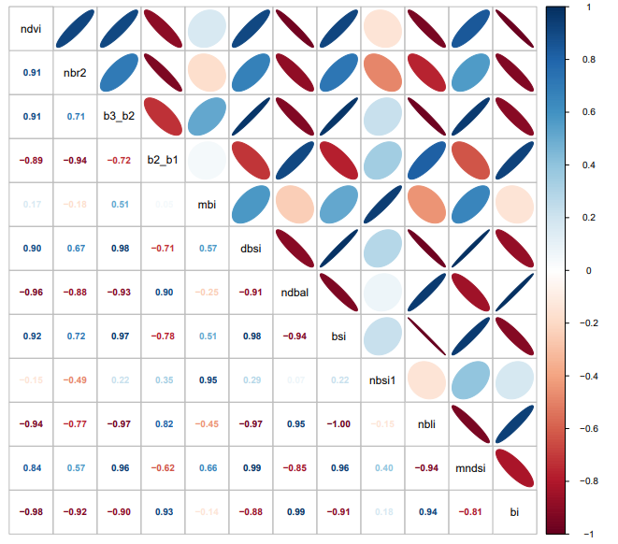

From the Correlation analysis, I determined and settled on 5 indices to use ranked from the index with the highest number of low correlation values to the index with the lowest number of low correlation values.

The indices were: MBI, NBR2, NDSI1, DBSI and MNDSI

1. GROUND SOIL SAMPLING SITES (SHAPEFILES)

From the provided polygon shapefiles showing the ground sampling that was conducted in Nyandarua County to collect soil samples for lab analysis which were: ID02 to ID27, I proceeded to:

1. Load them to Google earth engine
2. Match the filtering time period to the period for collection of the samples (January 8 – 12th 2024)
3. Calculate the 5 indices for each geometry
4. Collect the data on individual index value per geometry into .csv files

Below are the scatter plots of the index values against the sampling sites and the Mean:

**MBI**

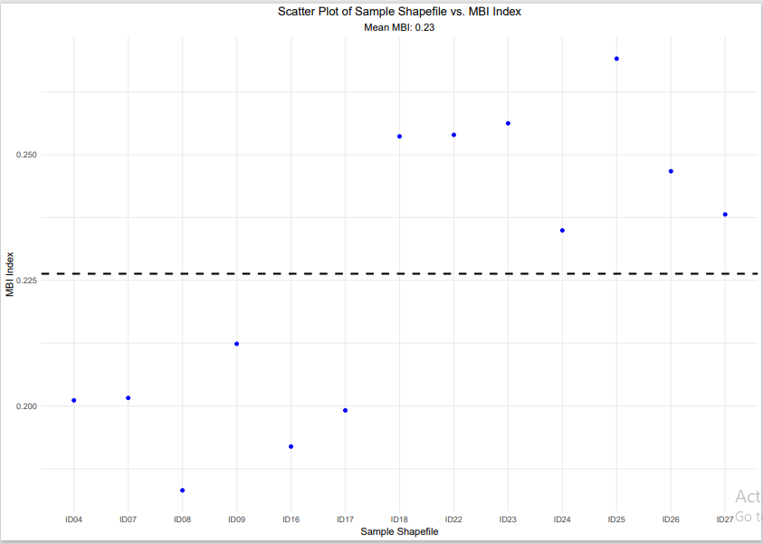

**NBR2**

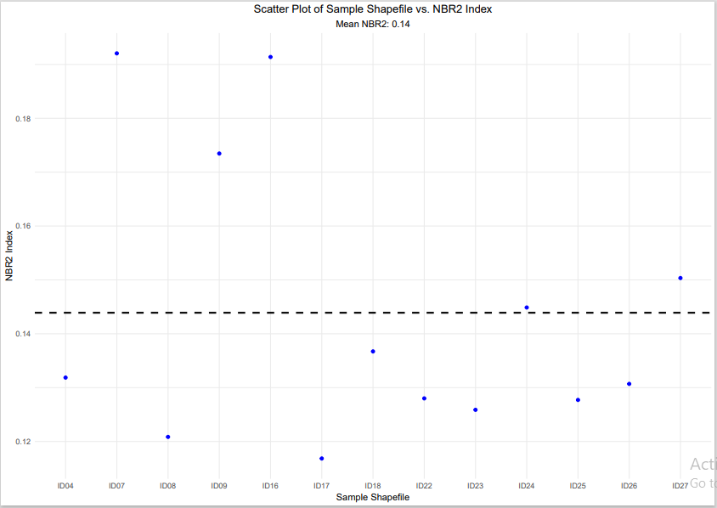

**NDSI1**

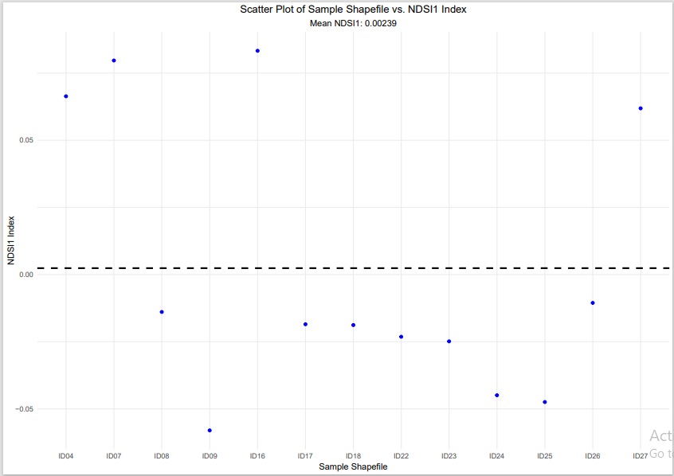

**DBSI**

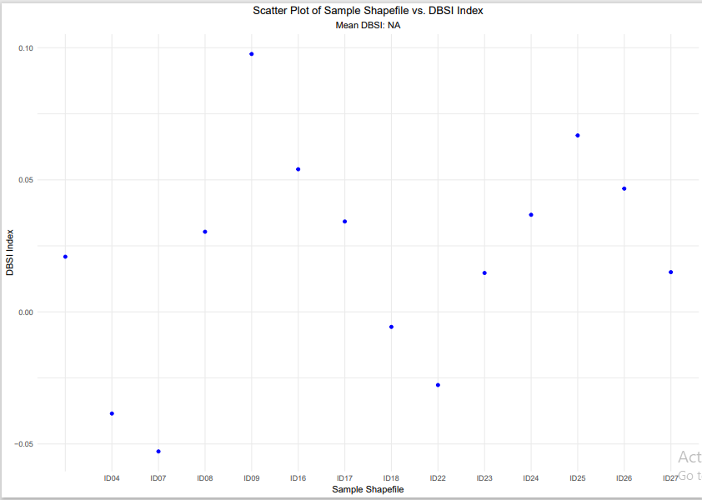

**MNDSI**

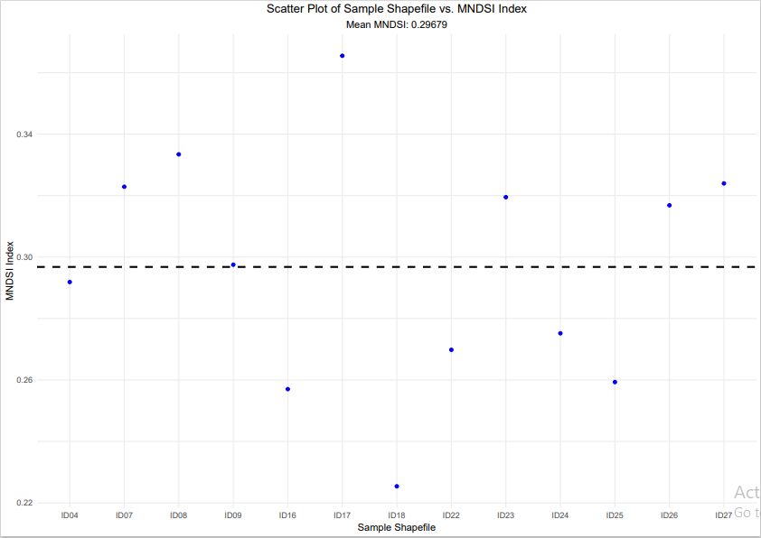

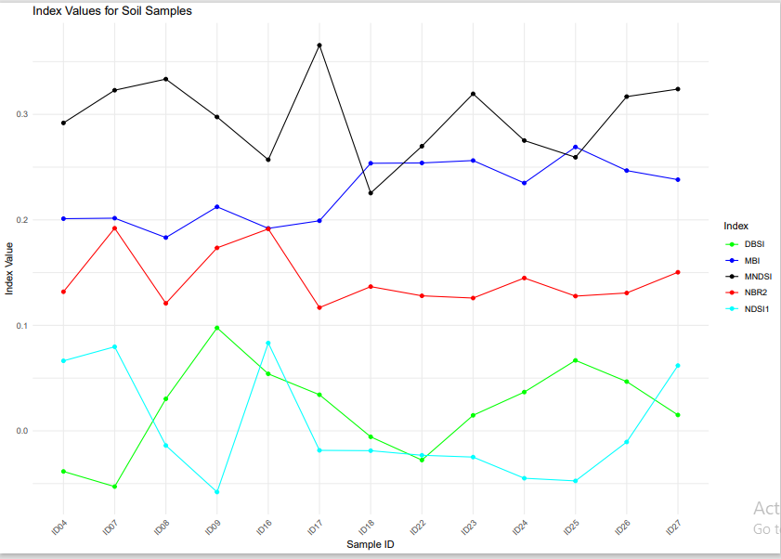

1. THRESHOLDING RANGES

From the mean values of the indices, I obtained the standard deviation and from the standard deviation, calculated the lower and upper bounds of the values which formed the threshold ranges I used to flag bare soil using the indices.

|  |  |  |  |  |  |
| --- | --- | --- | --- | --- | --- |
|  | MBI | NBR2 | DBSI | NDSI1 | MNDSI |
| MEAN | 0.23 | 0.14 | 0.021 | 0.00239 | 0.29679 |
| STD DEV | 0.0289 | 0.0258 | 0.0432 | 0.0510 | 0.0384 |
| LOWER BOUND | 0.1973 | 0.1181 | -0.0222 | -0.0486 | 0.26 |
| UPPER BOUND | 0.2553 | 0.1697 | 0.0642 | 0.0534 | 0.34 |
| THRESHOLD RANGE | (0.18 - 0.26) | (0.10 – 0.17) | (-0.03 – 0.07) | (-0.05 – 0.06) | (0.26 – 0.34) |

1. THRESHOLDING CRITERIA

I utilized the thresholds obtained above in Google earth engine as shown below:

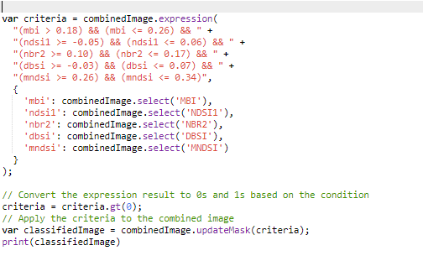

1. FOREST MASK AND URBAN AREA/ BUILT-UP AREA FOOTPRINT

To proceed with applying the thresholding to the imagery, I masked out Forested areas and Urban areas using the NDVI index following the criteria below:

1. Forest Area

I obtained the median composite image of the 10 years (2013 – 2023) and applied an NDVI threshold of 0.5 to flag forested areas being that they were densely vegetated and mask them out

1. Urban Area

I combined 16 NDVI images for the years 2015 to 2020 to form a 16-band image and set criteria to mask out pixels that had an NDVI in the range of 0.0 to 0.2 across all the NDVI bands and this was informed by the logic that built-up areas would have a constant low NDVI value across a period whereas bare soil would have varying high and low NDVI values due to the crop growth dynamics over time

1. RESULTS

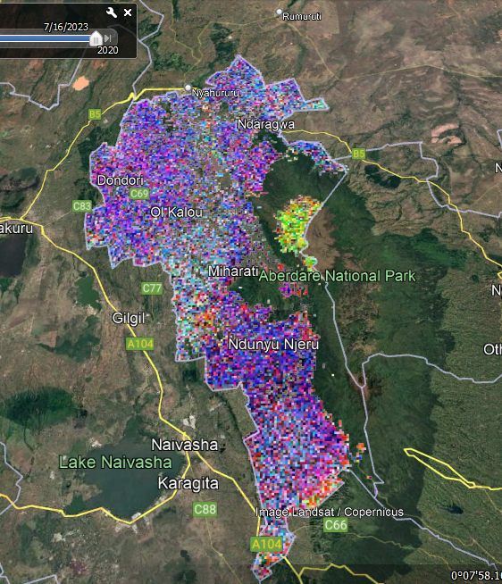2023 Annual Bare Soil Image visualized in Google earth Pro

VISUALIZATION OF THE BARE SOIL IMAGE OF NYANDARUA COUNTY (2013-2023) IN GOOGLE EARTH ENGINE

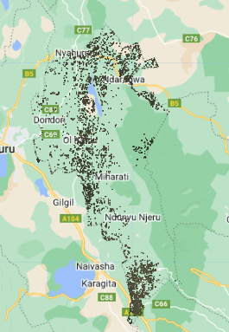

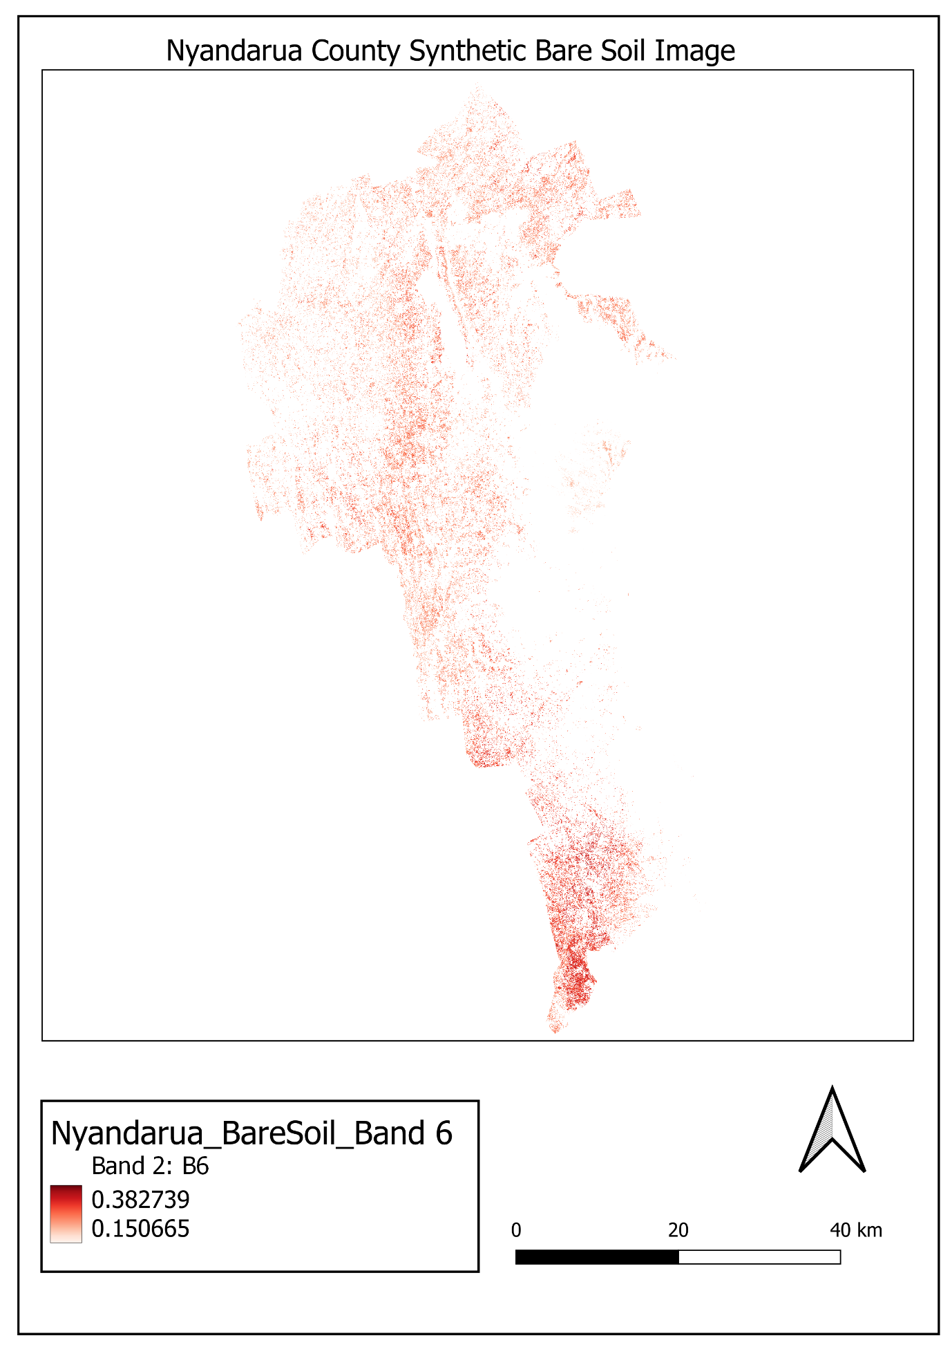

NYANDARUA SOIL MAP VS ESA WORLD COVER MAP

